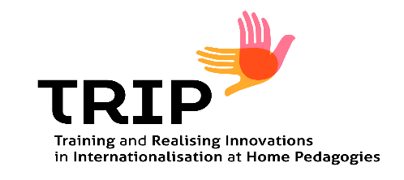


Here are five sample videos made by students who participated in the IVSC E-Module, working specifically on the theme of racial inclusion.
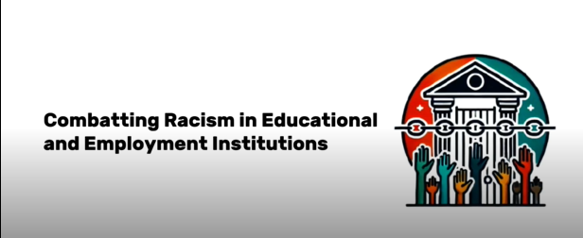
https://drive.google.com/file/d/10tkeiXfJZ9qdBh27GBRJo66tI4G4uenH/view?usp=drive_link
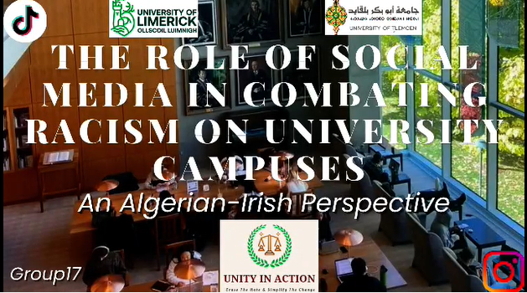
https://drive.google.com/file/d/1zBTlQenVIBZBEZd7GHeRfW5YS4U-7WAD/view?usp=drive_link

https://drive.google.com/file/d/1bju3JQVJYYI-Fd4GCXuSKHSWsorRlVoE/view?usp=drive_link
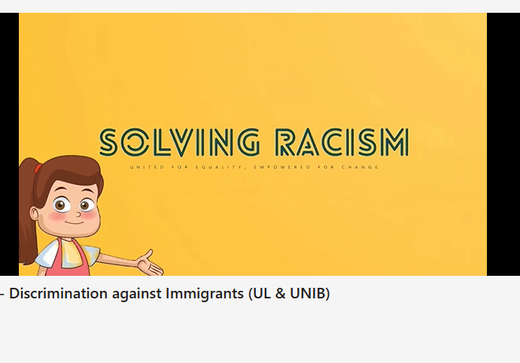
https://drive.google.com/file/d/1Ojn5Q7ES0JjGggF6ZkgbMizjBGcGTCLw/view?usp=sharing
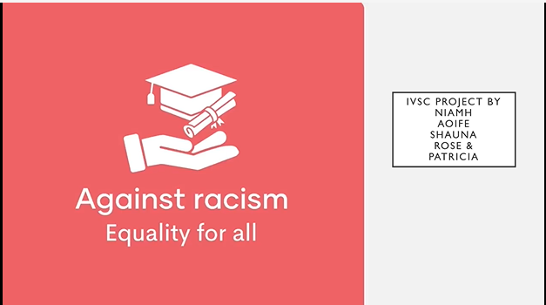
https://drive.google.com/file/d/1KBHFfDXimAIhRS4b4QHQmdIuUpP6uBvI/view?usp=drive_link
To view videos made by the students in relation to the additional themes of gender and the environment, please click on this You Tube link TRIP IVSC - YouTube.

